Back Propagation Example[1]

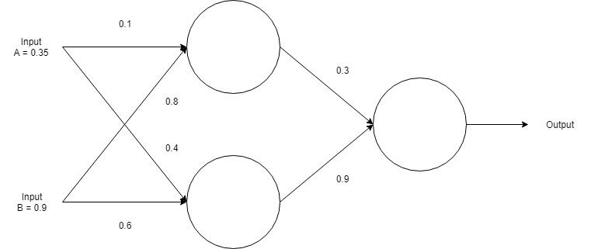

Assume a sigmoid activation function and

1. Perform a forward pass on the network
2. Perform a reverse pass (training) once (target = 0.5)
3. Perform a further forward pass and comment on the result

1)

Input to top neuron = (0.35 x 0.1) + (0.9 x 0.8) = 0.755. σ(0.755) = 0.6803

Input to bottom neuron = (0.35 x 0.4) + (0.9 x 0.6) = 0.68. σ(0.68) = 0.6637

Input to final neuron = (0.68 x 0.3) + (0.6637 x 0.9) = 0.80133. σ(0.80133) = 0.69

2)

Output error, δ = (target – output) x derivative of sigmoid function

= (target – output) x (1 – output) x (output)

= (0.69 – 0.5) x (1 – 0.69) x 0.69

= -0.0406

Adjusted weight for output layer:

w1+ = w1 + (δ x input) = 0.3 + (-0.0406 x 0.68) = 0.272392

w2+ = w2 + (δ x input) = 0.9 + (-0.0406 x 0.6637) = 0.87305

Output errors for hidden layer:

δ1 = δ x w1 = -0.0406 x 0.272392 x (1 – 0.69) x 0.69 = -0.002406

δ2 = δ x w2 = -0.0406 x 0.873050 x (1 – 0.69) x 0.69 = -0.007916

Adjusted weights for hidden layer

W3+ = 0.1 + (-002406 x 0.35) = 0.0916

W4+ = 0.8 + (-002406 x 0.90) = 0.7978

W5+ = 0.4 + (-007916 x 0.35) = 0.3972

W5+ = 0.6 + (-007916 x 0.90) = 0.5928

3)

1. Christopher MacLeod, An Introduction to Practical Neural Networks and Genetic Algorithms For Engineers and Scientist